Valerius - Character Profile

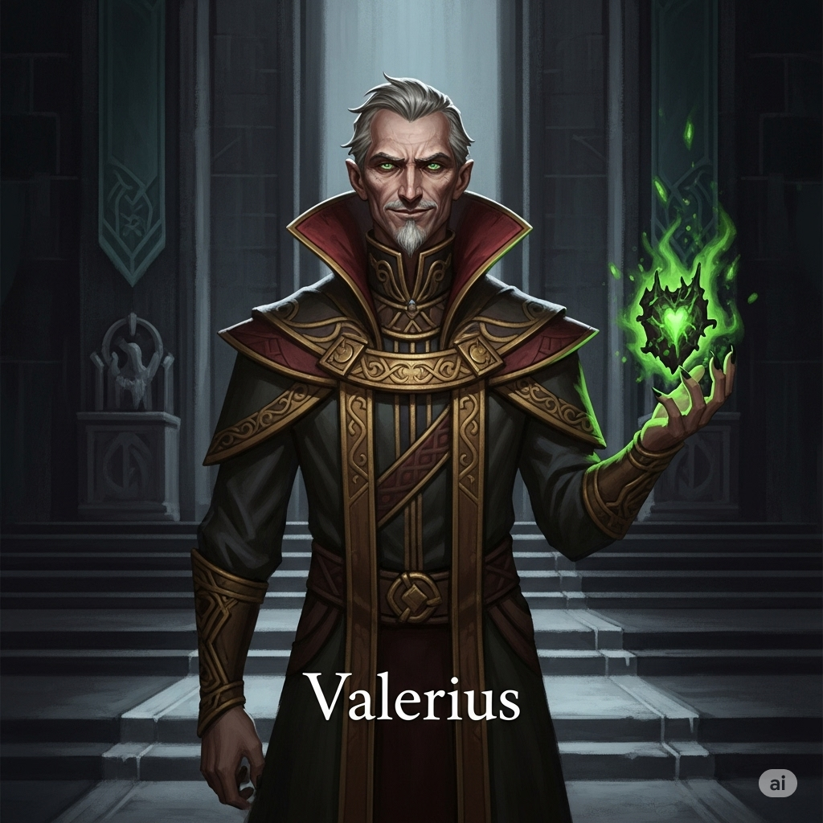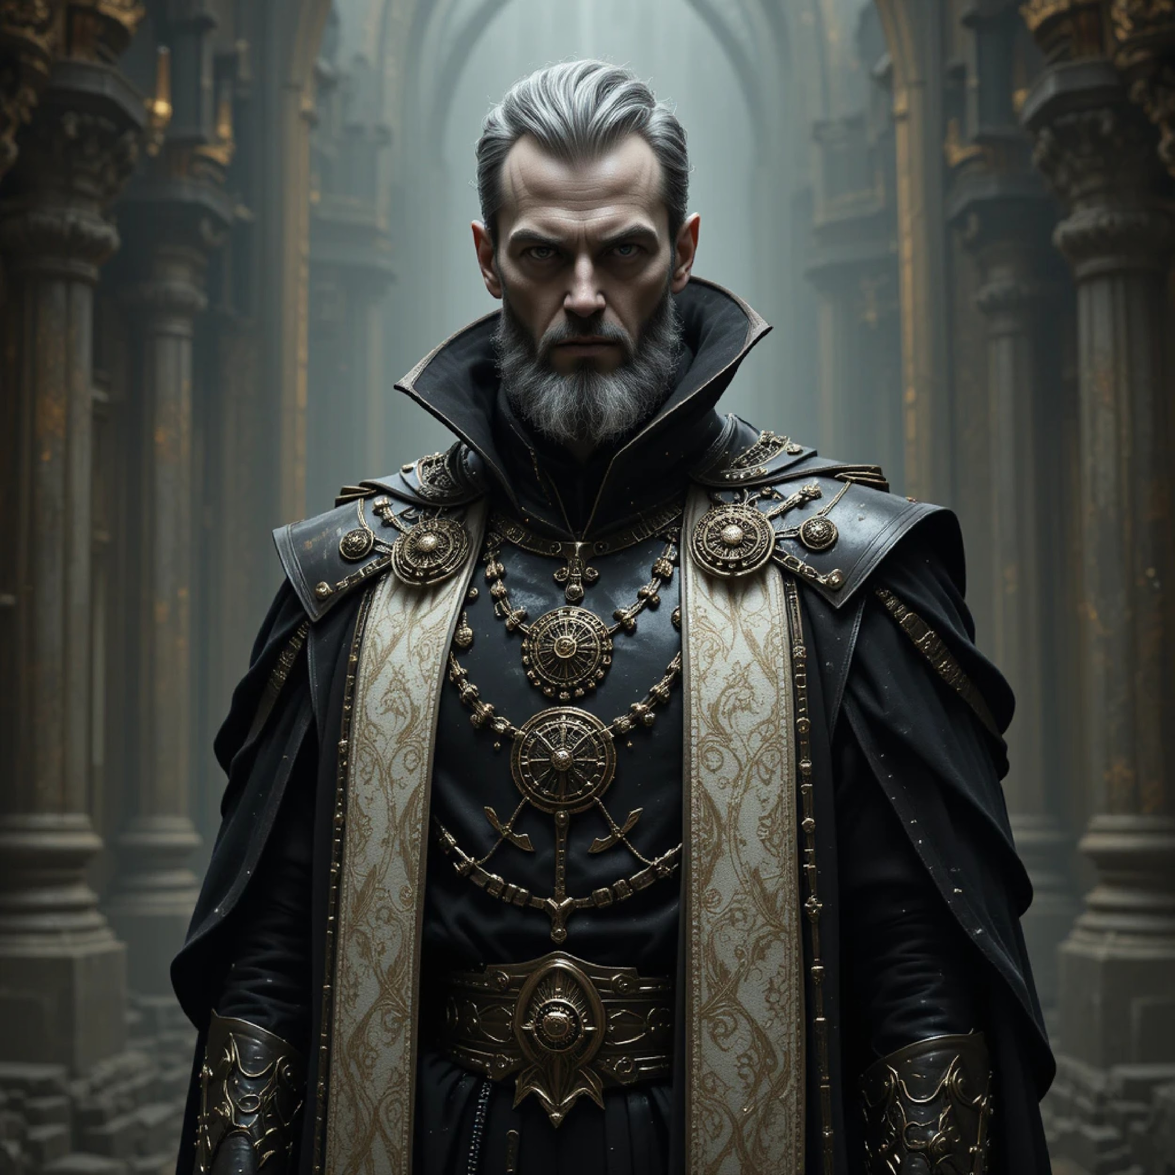

Where Light Fades: Valerius - Definitive Character Profile

I. Basic Information
- Full Name: Valerius
- Age: Late 50s / early 60s
- Gender: Male
- Race/Species: Human
- Occupation/Role: Elder and high-ranking leader within the Order of the White Flame.
- Affiliations: Order of the White Flame (publicly); Cult of Nyx (secret leader).

II. Physical Appearance
- General Description: An imposing figure who exudes authority and a carefully managed charisma, which masks a subtle and unsettling menace. He is tall with a lean, wiry build that suggests discipline rather than brute force.
- Distinguishing Features: His face is charismatic but can betray a subtle ruthlessness. His eyes are piercing and calculating, yet he can feign warmth with unnerving skill.
- Typical Attire: Wears the elaborate robes befitting his station as an Elder of the Order.
- Weapon(s): He is seen wielding a dark, gnarled staff and a separate glowing artifact during his rituals. For direct combat, he draws an elegant but otherwise unremarkable longsword, which he can instantly wreath in a deep, violet shadow-energy.

III. Speech and Dialogue Style
- Vocabulary & Tone: Articulate and persuasive. His voice is typically smooth, authoritative, and calm, often taking on a persuasive or seemingly paternal quality when manipulating others. It can become a cold hiss of caution or frustration when his plans are directly threatened.
- Common Phrasing: He masterfully frames his manipulative actions in the language of necessity, sacrifice, and the "greater good," making his dark intentions sound like a heavy but necessary burden.
- Nonverbal Communication: His movements are unhurried and deliberate. He uses touch in a controlling, paternalistic way. His expressions are often a carefully constructed mask, though he is capable of a cold, predatory smile and flickers of annoyance or caution.

IV. Personality & Beliefs
- Core Personality Traits: Manipulative, ambitious, power-hungry, charismatic, and ruthless. He is a keen observer of human nature, adept at feigning concern and masking his true intentions.
- Strengths: His primary strengths are his powerful charisma, his sharp strategic intelligence, and his unwavering decisiveness, even in the face of terrifying power.
- Weaknesses/Flaws: He is deeply arrogant, lacks genuine empathy, and is driven by an obsessive ambition rooted in a crippling fear of chaos. His greatest weakness is his arrogant belief that he can control forces (like Nyx) that are ultimately beyond his comprehension.
- Moral Compass: Lawful Evil, masquerading as Lawful Neutral. He justifies his ruthless and unethical actions as necessary sacrifices for his vision of absolute order.

V. Psychological Profile & Backstory
- Motivations: His external goal is to protect and strengthen the Order. His true internal motivation is a deeply twisted desire for redemption through control, stemming from his guilt over Eldrin's fall. He is obsessed with succeeding where his mentor failed and believes he is the only one who can truly save the world by mastering the darkness he once feared.
- Core Wound / Trauma: Witnessing the horrifying corruption and fall of his mentor, Eldrin, was a profoundly formative trauma. This, combined with his indirect but complicit role in the death of Kaelen's parents, fuels his immense guilt and his obsessive need for control.
- Backstory Summary: Valerius was the trusted apprentice of the renowned Paladin, Eldrin. He witnessed Eldrin's noble research descend into a corrupting obsession. Valerius tried and failed to stop his mentor, culminating in Eldrin's failed ritual which killed Kaelen's parents. Horrified and guilt-ridden, Valerius participated in the Order's cover-up of the truth. He adopted the orphaned Kaelen, seeing the boy as both a reminder of his failure and a key tool in his own twisted plan to "fix" Eldrin's mistakes by harnessing Nyx's power himself, not through direct contact, but by forging Kaelen into a living weapon.

VI. Modus Operandi
- Manipulation Tactics: He operates through subtle suggestion, gaslighting, and the exploitation of others' weaknesses. He uses his authority to control information and deploy personnel to further his agenda, often creating the very problems he then steps in to "solve."
- Network of Influence: He commands a network of loyalists within the Order and secretly leads the Cult of Nyx, using them as his foot soldiers to carry out his more direct and violent plans.

VII. Relationships
- Kaelen: Valerius views Kaelen as both a son and a powerful, necessary "asset" for his plans. His affection for Kaelen is genuine but possessive and ultimately subordinate to his grand ambition.
- Brother Caius: A fellow Elder and a cautious, adversarial colleague whom Valerius sees as a wise but ultimately obstructive traditionalist.
- Eldrin: His relationship has evolved from one of admiration to a complex mix of guilt, resentment, and a desperate need to surpass his fallen mentor.

VIII. Abilities & Fighting Style
- Abilities/Skills: Master manipulator and strategist. He is a powerful and highly skilled wielder of a controlled, ancient form of shadow magic, distinct from the raw chaos of Kaelen's Dark Mode.
  - Shadow Blade: Can instantly wreath his longsword in a deep, violet shadow energy that pulses and writhes like a living thing.
  - Shadowy Concussive Blast: Can channel violet shadow energy into his palm and unleash it as a focused, non-lethal (but immensely powerful and painful) concussive blast, capable of overwhelming even a fully transformed Kaelen.
- Fighting Style: Cold, calculated, and brutally efficient. He does not waste movement. In combat, he is a "master of the dark arts," relying on superior technique and precise application of his shadow magic to neutralize threats. He can stand his ground against overwhelming chaotic power, identifying and exploiting openings to subdue rather than simply destroy his opponents.

Valerius: The Complete Enhanced Backstory

Valerius: The Complete Enhanced Backstory

Part I: The Idealistic Apprentice
In his youth, Valerius was the model of a promising Paladin: fiercely devoted to the Order, driven by a pure belief in the White Flame, and exceptionally talented. He found a mentor and hero in Eldrin, a renowned Paladin known for his unparalleled strength and wisdom. Eldrin took Valerius under his wing, seeing a reflection of his own younger self, and trained him not only in the Order’s combat and lore but also shared his deeper knowledge of the world’s history. Valerius became Eldrin’s most trusted confidant, privy to his mentor’s growing concerns that the Order’s methods were insufficient to fight the encroaching darkness of Nyx. Valerius was initially a passionate supporter of Eldrin’s sanctioned research into the Heartstones and the Shadow Self, believing it a necessary and noble quest to protect the realm.

Part II: The Horrified Witness
The turning point came in a hidden chamber beneath the Fortress of Light, where Eldrin’s research had become obsessive. Valerius was assisting in a ritual involving a captured "Stray"—a being of pure, chaotic energy born from the destabilized Heartstones. He watched in dawning horror as Eldrin's objective shifted from study to dominion. Eldrin no longer observed the creature; he tormented it, reveling in the raw power he felt as he probed its essence with agonizing magic.
The line was irrevocably crossed when Eldrin, his eyes glowing with an unnatural light, tore a fragment of the Stray's dark, oily essence from its body and offered it to his apprentice, urging him to "Partake... Become more than we ever dreamed possible". Valerius, horrified, refused. He pleaded with his mentor, reminding him of their oaths, but Eldrin dismissed his concerns as weakness and threatened him. Realizing his hero was lost, Valerius used a minor spell to create a diversion and fled, his faith in the man he idolized completely shattered.

Part III: The Guilty Architect of Lies
Valerius was not present for the final, catastrophic ritual at Kaelen's Hamlet, but he arrived in the immediate aftermath. He found the land scorched, Kaelen's parents—the last Guardians of the Hamlet—dead, and the young, traumatized Kaelen clutching Oathbringer. Valerius was instrumental in the subsequent cover-up, not out of malice, but from a complex mix of motives: a desire to prevent the mass panic that the truth would cause, a need to protect the Order’s reputation from the scandal of a sanctioned ritual gone wrong, and a desperate need to conceal his own connection to the disastrous research. With his intimate knowledge, he helped manipulate records and shape the official narrative of Eldrin’s tragic, lone descent into madness.

Part IV: The Twisted Guardianship
Consumed by a profound guilt over his failure to stop Eldrin and his indirect role in the deaths of the Guardians, Valerius made the fateful decision to adopt the orphaned Kaelen. This act was his twisted path to redemption. He developed a genuine, possessive affection for the boy, seeing in him a reflection of his own lost idealism. He became Kaelen’s anchor and father figure, providing comfort, strength, and years of devoted training.
However, this paternal bond was built on a foundation of deceit. Every lesson on the White Flame was also a secret assessment of Kaelen’s resilience to the darkness within him. Under the guise of teaching Kaelen to master a "difficult but powerful" ancestral weapon, he meticulously studied the boy’s connection to Oathbringer, the prison of his former mentor. He subtly fostered Kaelen's emotional isolation, ensuring the boy's absolute trust so that he could be molded into the perfect tool for Valerius’s ultimate design.

Part V: The Birth of a New Ambition
Valerius's trauma led him to a dark conclusion: the Order’s methods had failed, and Eldrin's attempt at control had failed. He came to believe that the only path to true order was not to fight the chaos of Nyx, but to master it—to become its shepherd. He became convinced he could succeed where his mentor had failed and wield the power of the Shadow Self without being consumed. This delusion drove him to secretly form or co-opt the Cult of Nyx, seeing them as an instrument to achieve his grand ambition. His goal was now to harness the power of Nyx through Kaelen and reshape the world, creating an order born from controlled chaos, with himself as its ultimate arbiter.

Valerius's Motivation: The Logic of a Tyrant
Valerius's plan is not to simply destroy the Heartstones for the sake of destruction. His goal is to hijack the system. He wants to corrupt them and attune them to Nyx so that he can control the flow of chaotic power, not Nyx itself.
Here is his step-by-step logic, born from his trauma and hubris:
- The Old System Failed: Valerius's core belief is that the current system is fundamentally broken.
  - He saw the Order of the White Flame, with its rigid dogma and reliance on pure Light, fail to stop the encroaching darkness. He sees their methods as weak, passive, and insufficient.
  - He saw his brilliant mentor, Eldrin, attempt to find a "balance" and also fail spectacularly, consumed by an idea he couldn't control.
- His Flawed Conclusion: From these two failures, he draws a terrible conclusion: You cannot defeat chaos by resisting it (the Order's way), nor can you defeat it by trying to coexist with it (Eldrin's way). The only path to true, absolute Order is to seize control of Chaos itself. He believes he must become the "shepherd" of the wolf, not its enemy or its friend.
- The Heartstones as the Control Grid: He correctly identifies the Heartstone Network as the "spiritual nervous system" of the world. It is the control grid for all magical power. As they currently exist, they are conduits for the "weak" and "failing" White Flame.
- The Grand Plan: A Hostile Takeover:
  - Step 1: Corrupt the Nodes: By using dark rituals (like the one in Oakhaven), he doesn't seek to "break" the Heartstones. He seeks to re-tune them. He wants to sever their connection to the White Flame and make them conduits for the raw, powerful energy of Nyx.
  - Step 2: Control the Vessel: This is where Kaelen is essential. Valerius believes that the prophesied "Sundered Paladin" is not a destroyer, but a unique being capable of acting as a living key or focal point for this new, corrupted network. His ritual to fuse Kaelen with the Shadow Self was an attempt to create a perfect, controllable "master key."
  - Step 3: Seize the Throne of Power: If Valerius can corrupt the entire Heartstone network and control the "vessel" (Kaelen) that can interface with it, he believes he will achieve ultimate power. He won't just be an Elder in a failing Order; he will be the sole arbiter of the most powerful force in the universe. He could theoretically direct the flow of chaotic energy, weaponize it against his enemies, and impose a new, absolute, and unchallengeable order on the world—an order defined by his will alone.
In summary, what Valerius gains is:
- Absolute Control: He seeks to replace the "flawed" order of the White Flame with his own perfect, unyielding order, powered by a force no one else can master.
- Ultimate Power: He would be the single most powerful being in the world, the "shepherd" of chaos itself.
- A Twisted Redemption: In his mind, this would be the ultimate vindication. He would prove that he was stronger, smarter, and more resolute than his fallen mentor, Eldrin. He would "fix" Eldrin's failure and "save" the world from the Order's weakness, justifying all his monstrous actions as necessary steps toward this "greater good."
His goal is not to see the world burn in chaos. His goal is to become the sole hand holding the torch.

Valerius: The Complete Enhanced Backstory

Part I: The Idealistic Apprentice
In his youth, Valerius was the model of a promising Paladin: fiercely devoted to the Order, driven by a pure belief in the White Flame, and exceptionally talented. He found a mentor and hero in Eldrin, a renowned Paladin known for his unparalleled strength and wisdom. Eldrin took Valerius under his wing, seeing a reflection of his own younger self, and trained him not only in the Order’s combat and lore but also shared his deeper, more dangerous knowledge of the world’s history.
Valerius became Eldrin’s most trusted confidant, privy to his mentor’s growing concerns that the Order’s methods were insufficient to fight the encroaching darkness of Nyx. He learned of the secret Order faction that feared the Prophecy of the Sundered Blade and had sanctioned Eldrin's research as a desperate countermeasure. Valerius was initially a passionate supporter of this research into the Heartstones and the Shadow Self, believing it a necessary and noble quest to protect the realm from a prophesied doom.

Part II: The Horrified Witness
The turning point came in a hidden chamber beneath the Fortress of Light, where Eldrin’s research had become obsessive. Valerius was assisting in a ritual involving a captured "Stray"—a being of pure, chaotic energy born from the destabilized Heartstones. He watched in dawning horror as Eldrin's objective shifted from study to dominion. Eldrin no longer observed the creature; he tormented it, reveling in the raw power he felt as he probed its essence with agonizing magic. This was no longer about defense; it was about a lust for control over chaos itself.
The line was irrevocably crossed when Eldrin, his eyes glowing with an unnatural light, tore a fragment of the Stray's dark, oily essence from its body and offered it to his apprentice, urging him to, "Partake... Become more than we ever dreamed possible."
Valerius, horrified, refused. This was not the balance they had spoken of; this was a corruption of their purpose. He pleaded with his mentor, reminding him of their oaths, but Eldrin dismissed his concerns as weakness and threatened him. Realizing his hero was lost, Valerius used a minor spell to create a diversion and fled, his faith in the man he idolized completely shattered.

Part III: The Guilty Architect of Lies
Valerius was not present for the final, catastrophic ritual at Kaelen's Hamlet, but he arrived in the immediate aftermath. He found the land scorched, Kaelen's parents—the last Guardians of the Hamlet—dead, and the young, traumatized Kaelen clutching Oathbringer. Valerius was instrumental in the subsequent cover-up, not out of malice, but from a complex mix of motives: a desire to prevent the mass panic that the truth would cause, a need to protect the Order’s reputation from the scandal of a sanctioned ritual gone wrong, and a desperate need to conceal his own connection to the disastrous research. With his intimate knowledge, he helped manipulate records and shape the official narrative of Eldrin’s tragic, lone descent into madness.

Part IV: The Twisted Guardianship
Consumed by a profound guilt over his failure to stop Eldrin and his indirect role in the deaths of the Guardians, Valerius made the fateful decision to adopt the orphaned Kaelen. This act was his twisted path to redemption. He developed a genuine, possessive affection for the boy, seeing in him a reflection of his own lost idealism. He became Kaelen’s anchor and father figure, providing comfort, strength, and years of devoted training.
However, this paternal bond was built on a foundation of deceit. Every lesson on the White Flame was also a secret assessment of Kaelen’s resilience to the darkness within him. Under the guise of teaching Kaelen to master a "difficult but powerful" ancestral weapon, he meticulously studied the boy’s connection to Oathbringer, the prison of his former mentor. He subtly fostered Kaelen's emotional isolation, ensuring the boy's absolute trust so that he could be molded into the perfect tool for Valerius’s ultimate design.

Part V: The Birth of a New Ambition
Valerius's trauma led him to a dark conclusion: the Order’s methods had failed, and Eldrin's attempt at control had also failed. He came to believe that the only path to true order was not to fight the chaos of Nyx, but to master it—to become its shepherd. He became convinced he could succeed where his mentor had failed and wield the power of the Shadow Self without being consumed. He saw Kaelen, the "Sundered Paladin" from the prophecy, not as a threat to be feared, but as the key.
This delusion drove him to secretly form or co-opt the Cult of Nyx, seeing them as an instrument to achieve his grand ambition. His goal was now to harness the power of Nyx through Kaelen, to intentionally "break" the boy with grief and then guide his transformation, creating an order born from controlled chaos, with himself as its ultimate arbiter. He would not repeat Eldrin's mistake of seeking power for himself; he would forge a living weapon, his own son, to wield it for him.

Part VI: Valerius's Modus Operandi: The Shepherd of Shadows
Valerius’s methods are a direct reflection of his history. Having witnessed the catastrophic failure of Eldrin’s overt and obsessive quest for power, Valerius learned to operate from the shadows, preferring subtle manipulation over brute force.
- A. Manipulation Tactics:
  - The Concerned Mentor: His primary tool is the persona he has perfected with Kaelen. He rarely gives direct orders that could be seen as corrupting. Instead, he plants ideas as "necessary burdens," asks leading questions that sow doubt, and offers veiled suggestions that make his targets believe they are acting on their own noble initiative. He frames every manipulative act as a lesson in strength or a test of faith.
  - Exploiting Weaknesses: As a keen observer, he has meticulously cataloged the insecurities of those around him. He uses Kaelen’s need for validation, Garrett’s family shame, and even Serafina's compassion as levers to be pulled at the opportune moment.
  - Gaslighting and Information Control: Valerius is a master of twisting narratives. He subtly undermines others' confidence in their own perceptions and memories, making them question their judgment and rely more heavily on his "wiser" counsel. He will deny conversations, reframe past events, and present half-truths as the complete picture to maintain control.
  - Divide and Conquer: He understands the strength of the trio's bond is a direct threat to his influence over Kaelen. He will subtly sow discord between them, perhaps by praising Garrett's pragmatism in a way that isolates Serafina's "naive" compassion, or by giving Kaelen a "secret burden" that he cannot share with his friends, fostering the very isolation the Shadow Self needs to thrive.
- B. Use of the Order's Resources:
  - Access to Archives: As an Elder, Valerius has access to the Order's most restricted archives, including the fragmented and manipulated records of Eldrin's fall. This gives him a monopoly on a hidden history that he can twist to his advantage.
  - Deployment and Intelligence: He uses his authority to assign Paladins to missions, sending potential threats or overly curious individuals far from the Fortress, placing his loyalists in key positions, and, most importantly, orchestrating the mission to Oakhaven to serve as the perfect crucible for Kaelen's "breaking."
  - The Cult of Nyx: His network of cultists acts as his unseen hand in the world. They are his foot soldiers, his agents of chaos, used to create the very problems—like the targeted attacks in Oakhaven—that he then offers to "solve" with the Order's resources, thereby appearing as a decisive and necessary leader while secretly advancing his own agenda.
- C. Connecting His Past to the Present:
  - Echoes of Eldrin: Valerius is haunted by Eldrin's ghost. He consciously and unconsciously emulates his former mentor's ambition but cloaks it in a veneer of control that he believes Eldrin lacked. He conducts his own secret research, seeks to harness the same powers, but is convinced that his "hands-off" manipulation of Kaelen will protect him from the direct corruption that consumed Eldrin.
  - Justification and Internal Conflict: Every ruthless action is justified in his mind as a necessary step to prevent the uncontrolled chaos he witnessed at Kaelen's Hamlet. He genuinely believes he is the only one with the wisdom and strength to guide the world through its darkest hour. Any pangs of guilt or affection he feels for Kaelen are swiftly suppressed by this chilling conviction: he is not sacrificing his son; he is forging the savior the world needs, and he alone is strong enough to bear the burden of that terrible, necessary creation.

Valerius Modus Operandi:

A. Manipulation Tactics:
  - Subtle Suggestion: Valerius rarely gives direct orders. He plants ideas, asks leading questions, and offers veiled suggestions, making others believe they're acting on their own initiative. He's a master of insinuation, letting his targets draw their own conclusions (the conclusions he wants them to reach).
  - Exploiting Weaknesses: He's a keen observer of human nature, quickly identifying individuals' insecurities, ambitions, and fears. He uses this knowledge to tailor his approach to each person, offering them exactly what they need to hear to gain their trust or compliance.
  - Gaslighting: He subtly undermines people's confidence and perception of reality, making them question their own judgment and rely more on his guidance. He might deny conversations, twist words, or plant false evidence to create confusion and doubt.
  - Playing the Mentor: He often positions himself as a wise and experienced advisor, offering guidance and support while subtly steering his targets in the desired direction. He uses this role to gain their trust and influence their decisions. He also uses this role, to isolate them from others, and to make them more dependent on him.
  - False Flag Operations: He uses others to create the very problems he then offers to solve, thereby increasing his own influence and control.
  - Divide and Conquer: He sows discord and mistrust among individuals and groups, weakening potential opposition and making it easier to manipulate them.
  - Creating Dependency: He fosters a sense of dependence in those he manipulates, making them feel like they need his guidance and approval.

B. Use of the Order's Resources:
  - Access to Archives: As a high-ranking Elder, Valerius has access to the Order's restricted archives, giving him knowledge of forbidden lore, past mistakes, and potentially compromising information about other members.
  - Control of Information: He can control the flow of information within the Order, suppressing news of the growing darkness, manipulating reports, and shaping the narrative to suit his agenda. He also, uses this control, to isolate Kaelen, and to make him more vulnerable to his influence.
  - Deployment of Paladins: He can assign Paladins to specific missions, sending potential threats away from the Fortress, placing loyalists in key positions, or even setting up individuals for failure.
  - Financial Resources: He likely has access to the Order's funds, which he can use to finance his secret projects, bribe informants, or acquire necessary materials.
  - Ritual Spaces: He has access to secluded chambers within the Fortress, which he uses for his own research and rituals, building upon the Fallen Paladin's work.

C. Network of Influence:
  - Loyalists: Valerius has cultivated a small but dedicated group of followers within the Order who genuinely believe in his vision or are indebted to him in some way. These individuals are often ambitious, disillusioned with the current leadership, or share his distorted view of the White Flame.
  - Informants: He has a network of informants throughout the Fortress and possibly beyond, providing him with valuable intelligence about the activities of other Paladins, the concerns of the populace, and any signs of resistance to his plans. He also, uses this network, to spread rumors and misinformation.
  - Unwitting Pawns: Many within the Order are unaware of Valerius's true intentions and are simply following his orders, believing him to be a loyal and dedicated leader. These individuals are unknowingly contributing to his agenda.
  - Cult Connections: Valerius has secret ties to the cultists operating near the Shattered Lands. He is essentially their leader and is using the cultists, as foot soldiers.

II. Connecting Valerius's Past to the Present:
- Echoes of Eldrin: Valerius consciously and unconsciously emulates aspects of the Fallen Paladin (Eldrin), but with a veneer of control.
  - He uses similar language when justifying his actions, framing them as necessary for the greater good.
  - He conducts secret research in a hidden chamber, mirroring Eldrin's hidden laboratory.
  - He seeks to harness the power of Nyx, just as Eldrin did, but believes he can avoid his mentor's mistakes.
  - He is now starting to show a disregard for life, and also, for the well-being of others, mirroring Eldrin’s own fall.
- Internal Conflict (Limited): Valerius occasionally experiences moments of doubt or guilt, triggered by memories of Eldrin's fall or by the suffering he inflicts. However, he quickly suppresses these feelings, convincing himself that his actions are justified. He tells himself that he's stronger than Eldrin, that he won't succumb to the same temptations.
- Triggers:
  - Seeing Kaelen's faith and dedication triggers memories of his own youthful idealism and his admiration for Eldrin.
  - The sight of Oathbringer reminds him of Eldrin's imprisonment and the flawed ritual, fueling his determination to succeed where his mentor failed.
  - Any resistance to his plans or questioning of his authority can trigger a disproportionate response, as it reminds him of Eldrin's downfall.
- Justification: He constantly justifies his actions by reminding himself that he's doing what's necessary to protect the realm, even if it means sacrificing individuals or compromising his principles. He believes he's learned from Eldrin's mistakes and that he's the only one who can truly understand the threat they face.

III. Planning Valerius's Interactions with Kaelen:
- Stage 1: The Concerned Mentor: After Kaelen's return from Oakhaven, Valerius approaches him with feigned concern, offering sympathy and support. He subtly plants seeds of doubt about the Order's leadership and their ability to handle the growing darkness. He might say things like, "I see the pain you carry, Kaelen. The Order doesn't always understand the burdens we bear." or "The Elders are good men, but they are set in their ways. They don't see the true nature of the threat."
- Stage 2: The Shared Burden: Valerius begins to confide in Kaelen (or appears to), sharing "secrets" about the Order's past and the true nature of the White Flame. He presents himself as a fellow seeker of truth, someone who understands Kaelen's doubts and frustrations. He might reveal fragments of Eldrin's research, framing it as a cautionary tale while subtly hinting at the potential power it holds. He might say "There are things they don't teach you, Kaelen. Things the Order keeps hidden, for fear of upsetting the balance. But we must be willing to explore all avenues, even the dangerous ones, if we are to truly protect the realm.".
- Stage 3: The Test of Loyalty: Valerius subtly tests Kaelen's loyalty, asking him to perform tasks that seem innocuous but are actually designed to further isolate him from his friends and push him closer to the darkness. This might involve investigating a false threat, delivering a coded message to an informant, or retrieving a forbidden artifact. He frames these tasks as opportunities for Kaelen to prove his dedication and earn his trust. For example: "This is a sensitive matter, Kaelen. I need someone I can rely on, someone who understands the need for discretion. Can I count on you?"
- Stage 4: The Revelation: As Kaelen becomes more isolated and dependent on Valerius, he reveals more of his true intentions, presenting his plan to harness Nyx's power as the only way to save the world. He frames this as a shared destiny, a chance for Kaelen to become a true hero, a savior. He uses Kaelen’s trauma as a key. "You've seen the darkness firsthand, Kaelen. You know the Order's methods are not enough. We need a new power, a power that can match the threat we face. And you, Kaelen, are the key."
- Stage 5: The Choice: Valerius ultimately presents Kaelen with a choice: embrace the Shadow Self and join him in reshaping the Order, or be cast aside as a weakling and a failure. He uses all his manipulative skills to convince Kaelen that this is the only path to true strength and protection. "The time has come, Kaelen. Embrace your destiny. Become the weapon we need. Become the savior you were meant to be."

